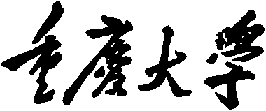 

**Personal Learning Portfolio**

**Course： English Academic Writing Teacher： Zhang Mei**

**Class： Major：**

**Name： Student Number：**

**Class Time： 2023.02-2023.07**

**Grade：**

|  |  |  |
| --- | --- | --- |
| **Self** | **Teaching Assistant** | **Teacher** |
|  |  |  |

**Comments：**

**Teacher (Signature)**

**Contents**

**Week 1**

1. **My learning**

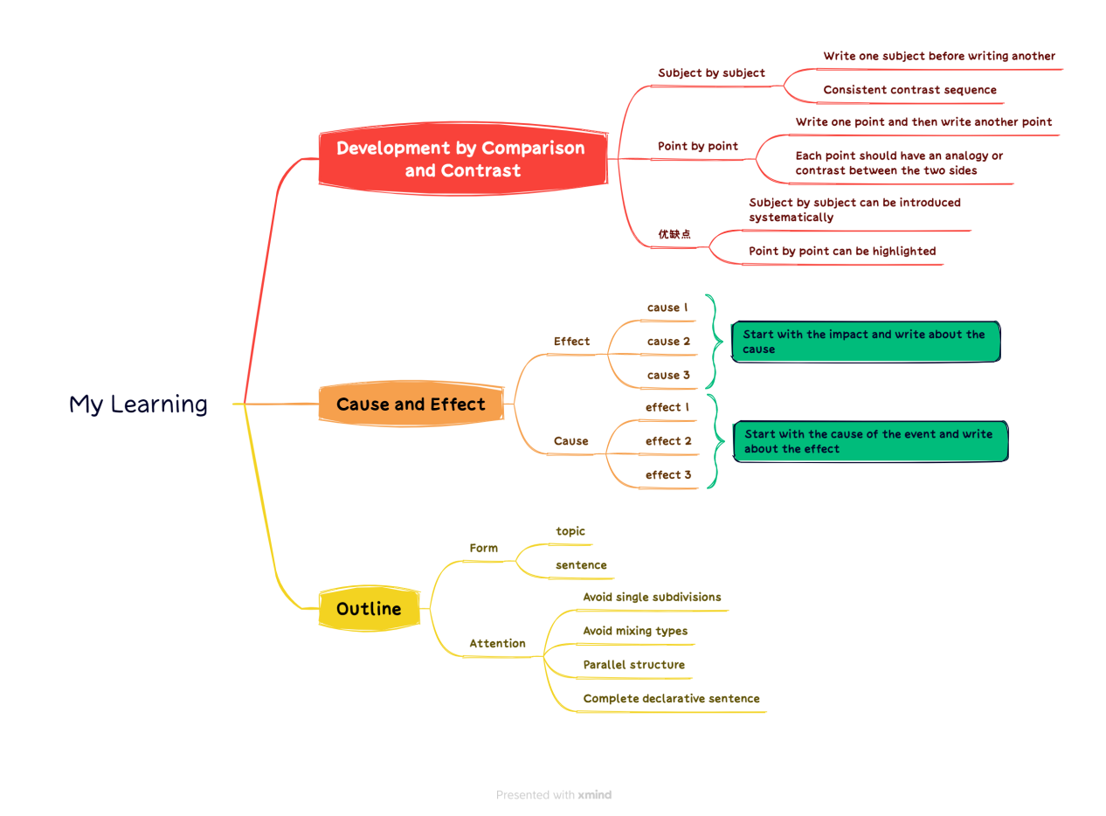

1. **Learning outcomes**

1. Introduce the topic with specific examples during the presentation.

2.when reporting can use the universal three-layer structure for reporting, the structure is clear.

3. Analogies and comparisons can highlight important points.

4. the report can choose photos and other forms to make the content more vivid.

5. the content of the article is relevant, the structure is clear, the proportion is reasonable, the language is beautiful.

6. Analogies require a wide range of objects.

1. **My behavior and attitude**

This week's study has begun to catch up with the pace of the teacher, I can understand the teacher's content well and make relevant notes. I took the CET-6 at the weekend, realized my shortcomings, and made great efforts to meet the next time.

1. **Improvement**

I should make better use of online resources such as MOOC for better learning and help myself in weak subjects.